Blood Of Oldest Woman In The World Reveals Secrets Of Longevity, Suggests We Can Live Longer
By Dana Dovey | Apr 24, 2014
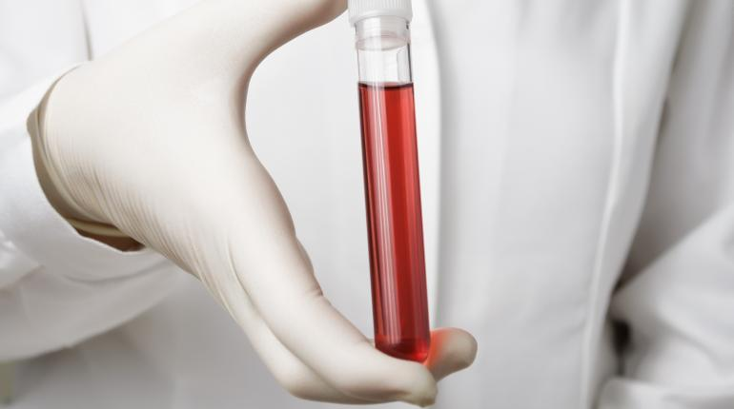
A study on the blood of the world's oldest woman has revealed that the secret to longevity is in our white blood cells. Photo courtesy of Shutterstock
It seems that 500 years after the death of Juan Ponce de Leon, science may have just discovered the mysterious fountain of youth. Only it’s not a fountain, and it’s definitely not in Florida. He actually had it all along — we all do. The secret to our longevity lies in our white blood cells. Astudy of blood and tissue samples from Hendrikje van Andel-Schipper, once the oldest woman in the world, revealed that death from old age is specifically caused by exhaustion of blood stem cells. Now that scientists have discovered what causes death, it automatically raises the question of what to do with this information. Some believe that manually replenishing these stem cells will result in the ability to fool Mother Nature and perhaps make death no longer inevitable.

Secrets in Blood
Born in 1890, van Andel-Schipper was known for her remarkable health in old age. She had a clear mind and disease-free body until her death in 2005. As she wished, upon her death van Andel-Schipper’s body was donated to science, and her blood and tissue samples helped scientists understand how the body is affected by old age. What scientists found is that our lifespan is limited by the capacity for stem cells to replenish,New Scientist reported. When stem cells are eventually no longer able to self-replenish, they gradually die off. The individual will no longer be able to replace tissue, and cells will soon succumb to a natural death of old age.
At the end of her life, two thirds of van Andel-Schipper’s remaining white blood cells had originated from just two stem cells. This suggests that most or all of the blood stem cells she had started with in life had burned out and died. Also, the telomeres on van Andel-Schipper’s white blood cells were drastically worn down. Telomeres are the protective tips on chromosomes that burn down like a candle wick each time a cell divides. During life, the number of active stem cells shrinks, and their telomeres shorten to the point at which they die. This point is called stem-cell exhaustion.

'Fountain of Youth'?
Does understanding the cause of death mean that we will be able to one day control death? Some scientists believe it may be possible to rejuvenate aging bodies with re-injections of stem cells saved from birth or early life. “If I took a sample now and gave it back to myself when I’m older, I would have long telomeres again—although it might only be possible with blood, not other tissue,” Henne Holstege, lead researcher of the study on van Andel-Schipper’s blood, told New Scientist. Rather than using this information to create a theoretical "fountain of youth," scientists hope that the results can be used in correlation with studies on Alzheimer’s disease to reveal why some people are more susceptible to the disease at an early age.
Van Andel-Schipper’s blood also gave some important insight into our bodies’ natural defenses against cancer. Researchers found that although there were many mutations in van Andel-Schipper’s blood, they were all harmless. These mutations were the result of mistaken replication of DNA, but due to their absence of cancer, researchers concluded that van Andel-Schipper had an advanced system for repairing or aborting cells with dangerous mutations. “When there is a mutation, there’s an opportunity for selection and some somatic mutations lead to cancer. Now we see the range of somatic mutations in normal, non-cancerous tissues like blood, so we can start to think about health consequences,” said Chris Tyler-Smith of the Wellcome Trust Sanger Institute in Hixton, Texas.

What are stem cells?
Stem cells are essentially the body’s raw materials. Under the right conditions in the body, or in a laboratory, stem cells divide to form more cells. These new cells will either become new stem cells or specialized cells with a more specific function, such as blood cells or brain cells. Stem cells are the only cell in the body that has the natural ability to form new cells types.

